Tools, Time and Trenches: Excavating the Prehistoric Site of Attirampakkam

Dr. Shanti Pappu and Dr. Kumar Akhilesh
Sharma Centre for Heritage Education, Chennai

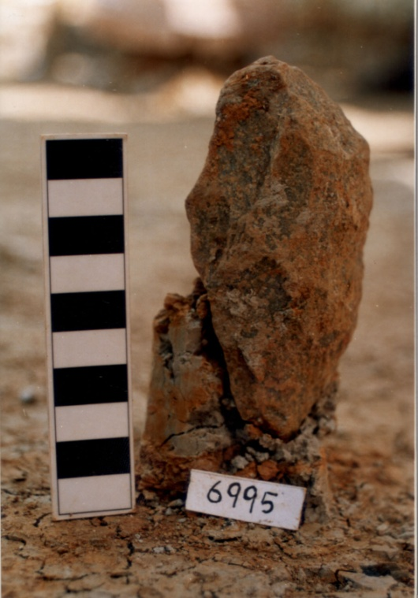This talk discusses our recent research into the prehistoric archaeology of northern Tamil Nadu, with a special focus on excavations at the site of Attirampakkam. Our multidisciplinary approach aims at investigating the nature of prehistoric sites in this region, establishing a chronology, and examining how populations adapted to past environmental changes. Excavations at Attirampakkam, revealed a long and complex history of occupation, beginning with the earliest Acheulian tool-making Lower Palaeolithic populations. This early occupation has recently been dated to >1.07 million years ago, through palaeomagnetic measurements and direct ²⁶Al/¹⁰Be burial dating of stone artifacts, with significant implications in terms of debates on population dispersals across Eurasia. Rock magnetics, clay mineralogy and other sedimentological studies indicate changing environments at this site. Studies of prehistoric stone tool technology indicate skill and planning exercised in raw material choices, tool manufacture and use. We also discuss applications of satellite remote sensing data in prehistoric research, in developing predictive models to locate new sites, and in planning for heritage management. We examine how these studies are important in the context of South Asian prehistoric archaeology.

About the speakers

Shanti Pappu is the Founder/Secretary of the Sharma Centre for Heritage Education. She obtained her Ph.D. from the Deccan College, Pune, specializing in prehistoric archaeology in Tamil Nadu. She was later awarded the Homi Bhabha Fellowship for research at the site of Attirampakkam, Tamil Nadu. She was also a Charles Wallace Fellow for research in the U.K., and later won the Earthwatch Young Scientist Award. She has published two books and more than 20 research publications in peer-reviewed national and international journals, as also one children’s book and popular articles. She also holds a degree in law, with specialization on cultural heritage laws of India.

Kumar Akhilesh is a Senior Research Fellow at the Sharma Centre for Heritage Education. His Ph.D. from the Deccan College, Pune was on the prehistoric archaeology of Jharkhand. He is currently Co-Director of the research project on prehistory and palaeoenvironments at Attirampakkam and other sites in Tamil Nadu. His special interests are in experimental archaeology (reconstructing ancient technology). His special areas of expertise are stone tool technology, and he is currently involved in analysis of artefacts from Attirampakkam and other sites in Tamil Nadu. He is also involved in a project on applications of satellite remote sensing and GIS in archaeology for purposes of research and heritage management. He has more than 15 research papers in peer reviewed national and international journals.

